BONDOC, ARSHIELA D.
REVIEWER IN EPP AND PANGKABUHAYAN WITH ENTREP
TEACH ELEM. 323B

UNIT I:
A. Importance of Edukasyong Pantahanan at Pangkabuhayan with Entrepreneurship in the K-12 Curriculum
Entrepreneurship education aids students from all socioeconomic backgrounds to think outside the box and nurture unconventional talents and skills. It creates opportunities, ensures social justice, instills confidence, and stimulates the economy. Entrepreneurship education is a lifelong learning process, starting as early as elementary school and progressing through all levels of education, including adult education.
Introducing young kids to entrepreneurship develops their initiative and helps them to be more creative and self-confident in whatever they undertake and to act in a socially responsible way.

Components of EPP in the K-12 Curriculum
1. Industrial Arts
❑ Industrial Arts has an important role to play as part of general education in our modern society. Each day our world becomes more mechanized and technical with the invention and production of more labor-saving devices. Many tradesmen and technicians are needed to install, operate, and service these modern pieces of equipment. Industrial Arts offers the student an opportunity to acquire some insight into various technical and trade areas. Lab or shop classes are not designed to turn out tradesmen or technicians but are for the purpose of acquainting the student with various occupations requiring some type of mental manual skill. Industrial Art class experiences will have carry-over value in later life, in job situations, in consumer knowledge, or possibly in home maintenance. Vocational Building Trades provides students an opportunity to explore twenty areas of pre-apprenticeship training for those that are considering construction as a career. Craftsmanship is not dead; it just has to be taught and honored.
A. CARPENTRY | is a skilled trade and a craft in which the primary work performed is the cutting, shaping and installation of building materials during the construction of buildings, ships, timber bridges, concrete formwork, etc. Carpenters traditionally worked with natural wood and did the rougher work such as framing, but today many other materials are also used and sometimes the finer trades of cabinetmaking and furniture building are considered carpentry.
B. PLUMBING | may be defined as the practice, materials, and fixtures used in installing, maintaining, and altering piping, fixtures, appliances, and appurtenances in connection with sanitary or storm drainage facilities, a venting system, and public or private water supply systems. Plumbing does not include drilling water wells; installing water softening equipment; or manufacturing or selling plumbing fixtures, appliances, equipment, or hardware. A plumbing system consists of three parts: an adequate potable water supply system; a safe, adequate drainage system; and ample fixtures and equipment.
C. ELECTRONICS | is the study of how to control the flow of electrons. It deals with circuits that are made with parts called components and connecting wires that control the flow of electricity and direct it to do useful things.
D. METAL WORKS | -is the process of shaping and reshaping metals to create useful objects, parts, assemblies, and large-scale structures. As a term it covers a wide and diverse range of processes, skills, and tools for producing objects on every scale: from huge ships, buildings, and bridges down to precise engine parts and delicate jewelry.
E. ELECTRICAL | is defined as something related to electricity, which is energy resulting from charged particles. When a wire carries electric current to your television or refrigerator, this is an example of an electrical wire.
F. ORTHOGRAPHIC DRAWING/CAD | are a very common style of drawing and are easily created with AutoCAD.

2. HOME ECONOMICS
❑ Is a field of study that is primarily concerned with strengthening family life and increasing productivity of individuals in the social economy. It synthesizes knowledge from arts and science-based disciplines to improve manipulative skills, organizational skills and social skills (James, 2003).
❑ Home economics is a broad field of knowledge and services concerned with all phases of family life. Lemchi (2001) also noted that Home Economics is a skill-oriented subject which is capable of equipping the individuals with basic skills and knowledge that will help them to be self-reliant and thereby contribute to the social and economic development of the individual, the family, and the nation at large.
A. FOOD, HEALTH, AND NUTRITION | Eating a well-balanced diet, with adequate nutrients and appropriate calories, is a fundamental requirement for continued health. An appropriate diet contributes to healthy development, healthy ageing and greater resilience against disease. Similarly, a poor or inappropriate diet places people at greater risk of infection and a range of chronic illnesses – including cancer, type 2 diabetes and cardiovascular disease.
B. TEXTILE AND CLOTHING | is about the design, manufacture and marketing of clothing and footwear and other textile products. Studying in this area includes learning about fabrics and other materials and about weaving, dyeing, printing, pattern-making, sewing, washing, etc.
C. PERSONAL FINANCE AND FAMILY RESOURCES | is the financial management which an individual or a family unit performs to budget, save, and spend monetary resources over time, taking into account various financial risks and future life events
D. CONSUMER SCIENCE | is a social discipline that focuses on the interaction between people and the environment. Some of the topics addressed by a specialist in consumer science are nutrition, aging, housing, food safety, community, and parenting.
E. HOUSEHOLD MANAGEMENT | refers to the various tasks and chores associated with the organization, financial management, and day-to-day operations of a home. Housekeeping is a term that is sometimes used to refer to the cleaning and physical upkeep of a house, as distinct from financial issues or outdoor maintenance.
F. HUMAN DEVELOPMENT | -refers to the physical, cognitive, and psychosocial development of humans throughout the lifespan. What types of development are involved in each of these three domains, or areas, of life? a. Physical development involves growth and changes in the body and brain, the senses, motor skills, and health and wellness. b. Cognitive development involves learning, attention, memory, language, thinking, reasoning, and creativity. c. Psychosocial development involves emotions, personality, and social relationships.

3. AGRICULTURE
❑Agriculture is the systematic raising of useful plants and animals under the management of man. It is a purposeful work through which the elements of nature are harnessed to produce plants and animals to meet human needs.
❑It is a broad industry engaged in the production of plants and animals for food and fiber, the provision for agricultural supplies and services, and the processing, marketing and distribution of agricultural products.
A. LIVESTOCK PRODUCTION | is commonly defined as domesticated animals raised in an agricultural setting to produce labor and commodities such as meat, eggs, milk, fur, leather, and wool.
B. AGRICULTURAL ECONOMICS | is commonly defined as domesticated animals raised in an agricultural setting to produce labor and commodities such as meat, eggs, milk, fur, leather, and wool.
C. CROP PRODUCTION | Irrigated farm areas mainly grow rice and sugarcane whereas rained areas are planted with coconut, corn and cassava. The Philippines' major agricultural products include rice, coconuts, corn, sugarcane, bananas, pineapples, and mangoes.
D. MODERN AGRICULTURE | is a term used to describe the wide type of production practices employed by American farmers. It makes use of hybrid seeds of selected variety of a single crop, technologically advanced equipment, and lots of energy subsidies in the form of irrigation water, fertilizers and pesticides.

B. Theories of Entrepreneurship
1. Economic Theory
❑ Mark Casson, in his book, The Entrepreneur — An Economic Theory, presented a functional definition of the entrepreneur and considered why the entrepreneurial function is so valuable. He emphasized that the demand for entrepreneurship stems from the need to adjust to change, and that the supply of entrepreneurship is limited firstly, by the scarcity of the requisite personal qualities, and secondly, by the difficulty of identifying them when they are available.
❑ He suggested that there are four main qualities which are crucial for a successful entrepreneur of which one — imagination — is almost entirely innate. The other three qualities may be enhanced. The problems encountered in screening for these qualities, and in enhancing the ones that are deficient, have a number of important implications for the development of a successful entrepreneurial career.
2. Sociological Theory
❑ Sociologists argue that entrepreneurship is most likely to emerge under a specific social culture. According to them, social sanctions, cultural values and role expectations are responsible for the emergence of entrepreneurship. Sociologists consider the entrepreneur as a role performer corresponding to the role expected by the society.
❑ According to Cochran the entrepreneur represents society’s model personality. His performance depends upon his own attitudes towards his occupation, the role expectations of sanctioning groups and the occupational requirements of the job. Society’s values are the most important determinant of the attitudes and role expectations.
❑ According to Horelitz, culturally marginal groups promote entrepreneurship and economic development. Such groups, because of their ambiguous position, are peculiarly suited to make creative adjustments and thereby develop genuine innovations.
❑ According to Derossi, Co-ordination at every stage-inception, maintenance and expansion is the function of an entrepreneur.
❑ Flaria thinks that entrepreneur needs two qualities:
a. Optimistic outlook: There is a possibility of change, the environment can be mastered and he himself can introduce the required change. He finds difficulties, challenging and stimulating; he thrives on them.
b. Dynamic: In a shared dynamic industry, new problems are seized upon as opportunities for testing one’s own capabilities.
3. Psychological Theory
❑ Among psychologists, Frank Young describes an entrepreneur as a change-agent. According to the advocates of this theory, entrepreneurship is most likely to emerge when a society has sufficient supply of individuals possessing particular psychological characteristics.
❑ K. L. Sharma maintains that entrepreneurs are men with qualities of leadership in solving persistent professional problems; but those persons likewise demonstrate eagerness to seize unusual opportunities.
❑ Uday Pareek and T.V. Rao describes entrepreneurship as a creative and innovative response to the environment. The entrepreneur is goal-oriented rather than means-oriented.
❑ Schumpeter believes that entrepreneurs are primarily motivated by an atavistic will to power, will find a private kingdom or will to conquer.
❑ Individuals with higher achievement motives tend to take keen interest in situations of high risk, desire for responsibility and a desire for a concrete measure of task performance.
4. Crop Production Theory
❑ Plants are autotrophic and therefore they fix the energy of the sun and manufacture food from simple inorganic substances for almost all other organisms through photosynthesis.
❑ Crop plants have a wide range of development and growth responses to sunlight, day length, temperature, nutrients, and water supply. Farmers do not, however, choose plants as crops for optimum adaptation to individual environments, but those that are preferred food, as in developing countries, or to meet market requirements, including global trade. In consequence, crops are managed to withstand environmental stresses. Socio-economic forces drive change in agriculture that is currently challenged to increase production by 70% to feed 9.2 billion by 2050.
5. Opportunity-Based Theory
❑ Prolific business management author, professor and corporate consultant, Peter Drucker put forward an opportunity-based theory. Drucker contends that entrepreneurs excel at seeing and taking advantage of possibilities created by social, technological and cultural changes.
❑ For example, where a business that caters to senior citizens might view a sudden influx of younger residents to a neighborhood as a potential death stroke, an entrepreneur might see it as a chance to open a new club.
6. Resource-based Theories
❑ Resource-based theories focus on the way individuals leverage different types of resources to get entrepreneurial efforts off the ground. Access to capital improves the chances of getting a new venture off the ground, but entrepreneurs often start ventures with little ready capital.
❑ Other types of resources entrepreneurs might leverage include social networks and the information they provide, as well as human resources, such as education. In some cases, the intangible elements of leadership the entrepreneur adds to the mix operate as resource that a business cannot replace.

BONDOC, ARSHIELA D.
REVIEWER IN EPP AND PANGKABUHAYAN WITH ENTREP
TEACH ELEM. 323B

LESSON 2: ROBERT GAGNE AND LEARNING HIERARCHY

ROBERT GAGNE
❑ Robert Mills Gagné (August 21, 1916 – April 28, 2002) was an American educational psychologist best known for his "Conditions of Learning". Gagné pioneered the science of instruction during World War II when he worked with the Army Air Corps training pilots. He went on to develop a series of studies and works that simplified and explained what he and others believed to be 'good instruction.’
❑ In 1965 Robert Gagne published his book entitled The Conditions of Learning. In his book, Gagne (1965) described the analysis of learning objectives, and how these different classes of learning objectives relate to the appropriate instructional designs.
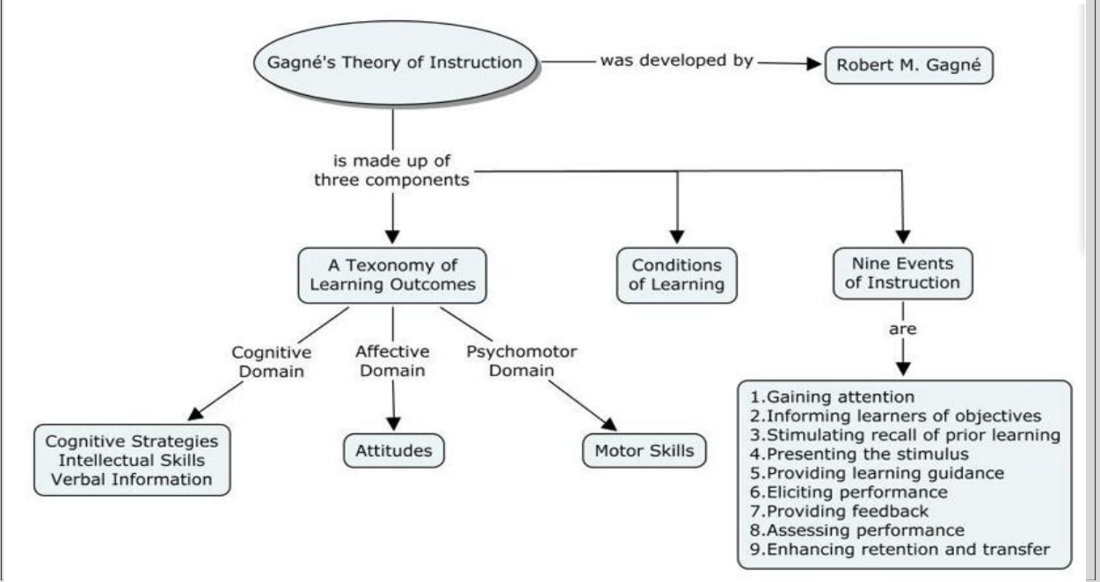
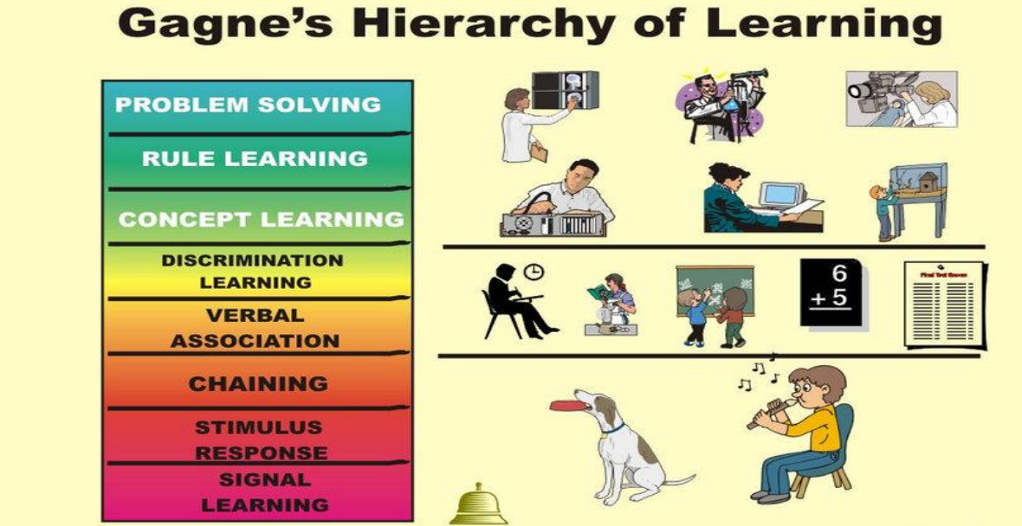
Robert’s Gagne Hierarchy of Learning
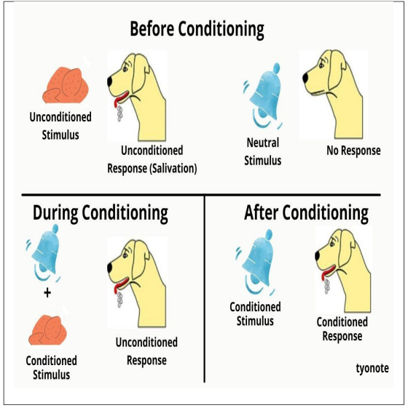
1. SIGNAL LEARNING
❑ This is the simplest form of learning and consists essentially of the classical conditioning first described by the behavioral psychologist Pavlov. In this, the subject is 'conditioned' to emit a desired response as a result of a stimulus that would not normally produce that response. This is done by first exposing the subject to the chosen stimulus (known as the conditioned stimulus) along with another stimulus (known as the unconditioned stimulus) which produces the desired response naturally; after a certain number of repetitions of the double stimulus, it is found that the subject emits the desired response when exposed to the conditioned stimulus on its own. The applications of classical conditioning in facilitating human learning are, however, very limited.
2. Stimulus- response Learning
❑ This somewhat more sophisticated form of learning, which is also known as operant conditioning, was originally developed by Skinner. It involves developing desired stimulus-response bonds in the subject through a carefully-planned reinforcement schedule based on the use of 'rewards' and 'punishments’.
❑ Operant conditioning differs from classical conditioning in that the reinforcing agent (the 'reward' or 'punishment') is presented after the response. It is this type of conditioning that forms the basis of programmed learning in all its various manifestations.
3. Chaining
❑ This is a more advanced form of learning in which the subject develops the ability to connect two or more previously- learned stimulusresponse bonds into a linked sequence. It is the process whereby most complex psychomotor skills (eg riding a bicycle or playing the piano) are learned.
4. Verbal Association
❑ This is a form of chaining in which the links between the items being connected are verbal in nature. Verbal association is one of the key processes in the development of language skills.
5. Discrimination on Learning
❑ This involves developing the ability to make appropriate (different) responses to a series of similar stimuli that differ in a systematic way. The process is made more complex (and hence more difficult) by the phenomenon of interference, whereby one piece of learning inhibits another. Interference is thought to be one of the main causes of forgetting.
6. Concept Learning
❑ This involves developing the ability to make a consistent response to different stimuli that form a common class or category of some sort. It forms the basis of the ability to generalize, classify etc.

7. Rule Learning
❑ This is a very-high-level cognitive process that involves being able to learn relationships between concepts and apply these relationships in different situations, including situations not previously encountered. It forms the basis of the learning of general rules, procedures, etc.
8. Problem-solving
❑ This is the highest level of cognitive process according to Gagné. It involves developing the ability to invent a complex rule, algorithm or procedure for the purpose of solving one particular problem, and then using the method to solve other problems of a similar nature.

GAGNE 9 EVENTS OF INSTRUCTION

1. Gain attention of the students
Ensure the learners are ready to learn and participate in activities by presenting a stimulus to capture their attention.
These are a few methods for capturing learners’ attention:
- Stimulate students with novelty, uncertainty, and surprise
- Pose thought-provoking questions to students
- Have students pose questions to be answered by other students
- Lead an ice breaker activity

2. Inform students of the objectives
Inform students of the objectives or outcomes for the course and individual lessons to help them understand what they are expected to learn and do. Provide objectives before instruction begins.
Here are some methods for stating the outcomes:
- Describe required performance
- Describe criteria for standard performance
- Have learners establish criteria for standard performance
- Include course objectives on assessment prompts
3. Stimulate recall of prior learning
Help students make sense of new information by relating it to something they already know or something they have already experienced.
There are numerous methods for stimulating recall:
- Ask questions about previous experiences
- Ask students about their understanding of previous concepts
- Relate previous course information to the current topic
- Have students incorporate prior learning into current activities

4. Present the content
Use strategies to present and cue lesson content to provide more effective instruction. Organize and group content in meaningful ways, and provide explanations after demonstrations.
The following are ways to present and cue lesson content:
- Present multiple versions of the same content (e.g. video, demonstration, lecture, podcast, group work, etc.)
- Use a variety of media to engage students in learning
- Incorporate active learning strategies to keep students involved
- Provide access to content on Blackboard so students can access it outside of class

5. Provide learning guidance
Advise students of strategies to aid them in learning content and of resources available. In other words, help students learn how to learn.
The following are examples of methods for providing learning guidance:
- Provide instructional support as needed – i.e. scaffolding that can be removed slowly as the student learns and masters the task or content
- Model varied learning strategies – e.g. mnemonics, concept mapping, role playing, visualizing
- Use examples and non-examples – examples help students see what to do, while non-examples help students see what not to do
- Provide case studies, visual images, analogies, and metaphors – Case studies provide real world application, visual images assist in making visual associations, and analogies and metaphors use familiar content to help students connect with new concepts
6. Elicit performance (practice)
Have students apply what they have learned to reinforce new skills and knowledge and to confirm correct understanding of course concepts.
Here are a few ways to activate learner processing:
- Facilitate student activities – e.g. ask deep-learning questions, have students collaborate with their peers, facilitate practical laboratory exercises
- Provide formative assessment opportunities – e.g. written assignments, individual or group projects, presentations
- Design effective quizzes and tests – i.e. test students in ways that allow them to demonstrate their comprehension and application of course concepts (as opposed to simply memorization and recall)

7. Provide feedback
Provide timely feedback of students’ performance to assess and facilitate learning and to allow students to identify gaps in understanding before it is too late.
The following are some types of feedback you may provide to students:
- Confirmatory feedback informs the student that they did what they were supposed to do. This type of feedback does not tell the student what she needs to improve, but it encourages the learner.
- Evaluative feedback apprises the student of the accuracy of their performance or response but does not provide guidance on how to progress.
- Remedial feedback directs students to find the correct answer but does not provide the correct answer.
- Descriptive or analytic feedback provides the student with suggestions, directives, and information to help them improve their performance.
- Peer-evaluation and self-evaluation help learners identify learning gaps and performance shortcomings in their own and peers’ work.
8. Assess performance
Test whether the expected learning outcomes have been achieved on previously stated course objectives.
Some methods for testing learning include the following:
- Administer pre- and post-tests to check for progression of competency in content or skills
- Embed formative assessment opportunities throughout instruction using oral questioning, short active learning activities, or quizzes
- Implement a variety of assessment methods to provide students with multiple opportunities to demonstrate proficiency
- Craft objective, effective rubrics to assess written assignments, projects, or presentations
Implement a variety of assessment methods to provide students with multiple opportunities to demonstrate proficiency.

9. Enhance retention and transfer
Help learners retain more information by providing them opportunities to connect course concepts to potential real-world applications.
The following are methods to help learners internalize new knowledge:
- Avoid isolating course content. Associate course concepts with prior (and future) concepts and build upon prior (and preview future) learning to reinforce connections.
- Continually incorporate questions from previous tests in subsequent examinations to reinforce course information.
- Have students convert information learned in one format into another format (e.g. verbal or visuospatial). For instance, requiring students to create a concept map to represent connections between ideas (Halpern & Hakel, 2003, p. 39).
- To promote deep learning, clearly articulate your lesson goals, use your specific goals to guide your instructional design, and align learning activities to lesson goals (Halpern & Hakel, 2003, p. 41).

BONDOC, ARSHIELA D.
REVIEWER IN EPP AND PANGKABUHAYAN WITH ENTREP
TEACH ELEM. 323B

Unit 2: Learning Theories and Their Impact to EPP Teaching
Learning Theory
Learning theory describes how students receive, process, and retain knowledge during learning.
Cognitive, emotional, and environmental influences, as well as prior experience, all play a part in how understanding, or a world view, is acquired or changed and knowledge and skills retained.
Learning design should be based on learning theories because:
Theories provide a basis to understand how people learn and a way to explain, describe, analyze and predict learning. In that sense, a theory helps us make more informed decisions around the design, development and delivery of learning.
There are different learning theories (behaviourism, cognitivism, constructivism, connectivism, etc.). These theorists have thought deeply about learning and contemplated and researched it extensively. Learning designers can leverage this knowledge to think critically about learning and education.
Learning theories offer frameworks that help understand how information is used, how knowledge is created and how learning takes place. Learning designers can apply these frameworks according to different learning and learner needs and make more informed decisions about choosing the right instructional practices.

Learning Theories
Behaviorism
❑The theory of behaviorism focuses on the study of observable and measurable behavior. It emphasizes that behavior is mostly learned through conditioning and reinforcement (rewards and punishment). It does not give much attention to the mind and the possibility of thought processes occurring in the mind.
❑Contributions in the development of the behaviorist theory largely came from Pavlov, Watson, Thorndike and Skinner.
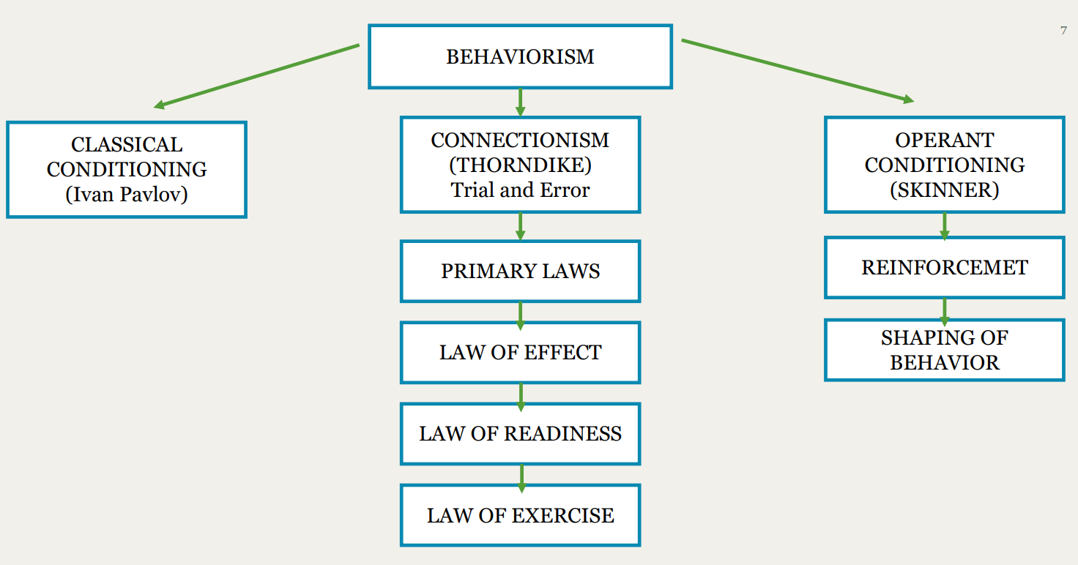
Ivan Pavlov
❑ a Russian physiologist, is well known for his work in classical conditioning or stimulus substitution. Pavlov’s most renowned experiment involved meat, a dog and a bell. Initially, Pavlov was measuring the dog’s salivation in order to study digestion. This is when he stumbled upon classical conditioning.
❑ Pavlov’s Experiment. Before conditioning, ringing the bell (neutral stimulus) caused no response from the dog. Placing food (unconditioned stimulus) in front of the dog-initiated salivation (unconditional response). During conditioning, the bell was rung a few seconds before the dog was presented with food. After conditioning, the ringing of the bell (Conditioned stimulus) alone produced salivation (conditioned response). This is classical conditioning.

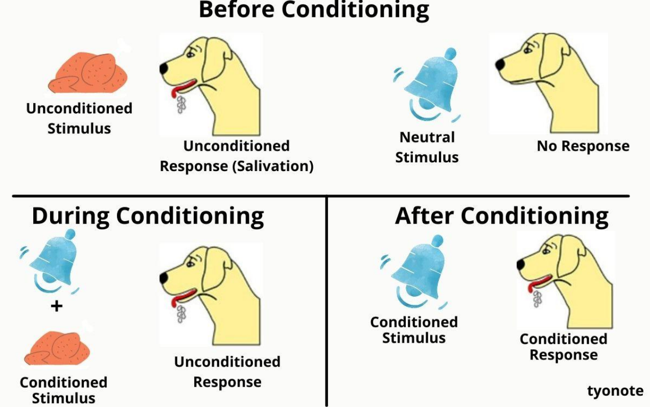

Edward Thorndike
❑ Edward Thorndike’s Connectionism theory gave us the original S-R framework of behavioral psychology. More than a hundred years ago he wrote a textbook entitled, Educational Psychology. He was the first one to use this term. He explained that learning is the result if associations forming between stimuli (S) and responses (R). Such associations or “habits” become strengthened or weakened by the nature and frequency of the S-R pairings. The model for S-R theory was trial and error learning in which certain responses came to be repeated more than others because of rewards. The main principle of connectionism (like all behavioral theory) was that learning could be adequately explained without considering any unobservable internal states
❑ Thorndike’s theory on connectionism, states that learning has taken place when a strong connection or bond between stimulus and response is formed.

3 Primary Laws
1. Law of Readiness
First primary law of learning, according to him, is the ‘Law or Readiness’ or the ‘Law of Action Tendency’, which means that learning takes place when an action tendency’ is aroused through preparatory adjustment, set or attitude.

Readiness means a preparation for action. If one is not prepared to learn, learning cannot be automatically instilled in him, for example, unless the typist, in order to learn typing prepares himself to start, he would not make much progress in a lethargic and unprepared manner.

2. Law of Exercise
The second law of learning is the ‘Law of Exercise’, which means that drill, or practice helps in increasing efficiency and durability of learning and according to Thorndike’s S-R Bond Theory, the connections are strengthened with trail or practice and the connections are weakened when trial or practice is discontinued.

The ‘law of exercise’, therefore, is also understood as the ‘law of use and disuse’ in which case connections or bonds made in the brain cortex are weakened or loosened.

3. Law of Effect
The third law is the ‘Law of Effect’, according to which the trial or steps leading to satisfaction stamps in the bond or connection. Satisfying states lead to consolidation and strengthening of the connection, whereas dis-satisfaction, annoyance or pain leads to the weakening or stamping out of the connections.
❑In fact, the ‘law or effect’ signifies that if the responses satisfy the subject, they are learnt and selected. While those which are not satisfying are eliminated. Teaching, therefore, must be pleasing. The educator must obey the tastes and interests of his pupils. In other words, greater the satisfaction stronger will be the motive to learn. Thus, intensity is an important condition of the ‘law of effect

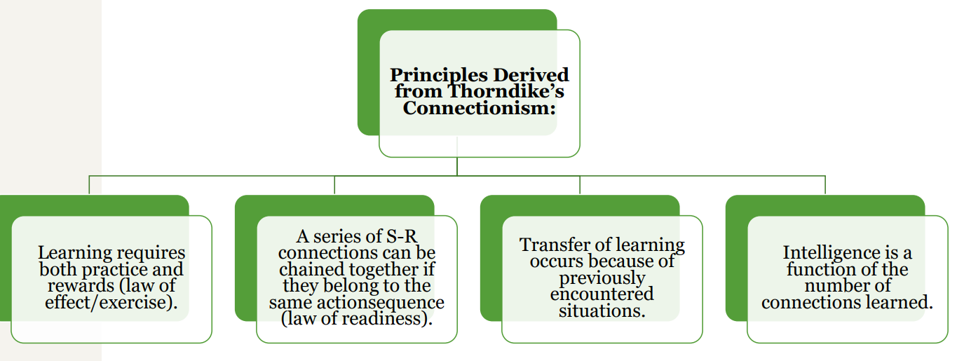

John Watson
❑ He was the first American psychologist to work with Pavlov’s ideas. He too was initially involved in animal studies, then later became involved in human behavior research. He considered that humans are born with a few reflexes and the emotional reactions of love and rage. All other behavior is learned through stimulus-response associations through conditioning.
❑ He believed in the power of conditioning so much that he said that if he is given a dozen healthy infants, he can make them into anything you want them to be, basically through making stimulus response connections through conditioning.

Watson applied classical conditioning in his experiment concerning Albert, a young child and a white rat. In the beginning, Albert was not afraid of the rat; but Watson made a sudden noise each time Albert touched the rat. Because Albert was frightened by the loud noise, he soon became conditioned fear and avoid the rat. Later, the child’s response was generalized to other small animals. Now, he was also afraid of small animals. Watson then “extinguished” or made the child “unlearn” fear by showing the rat without the loud noise. Surely, Watson’s research methods would be questioned today, nevertheless, his work di clearly show the role of conditioning in the development of emotional responses to certain stimuli. This may help us understand the fears, phobias, and prejudices that people develop.

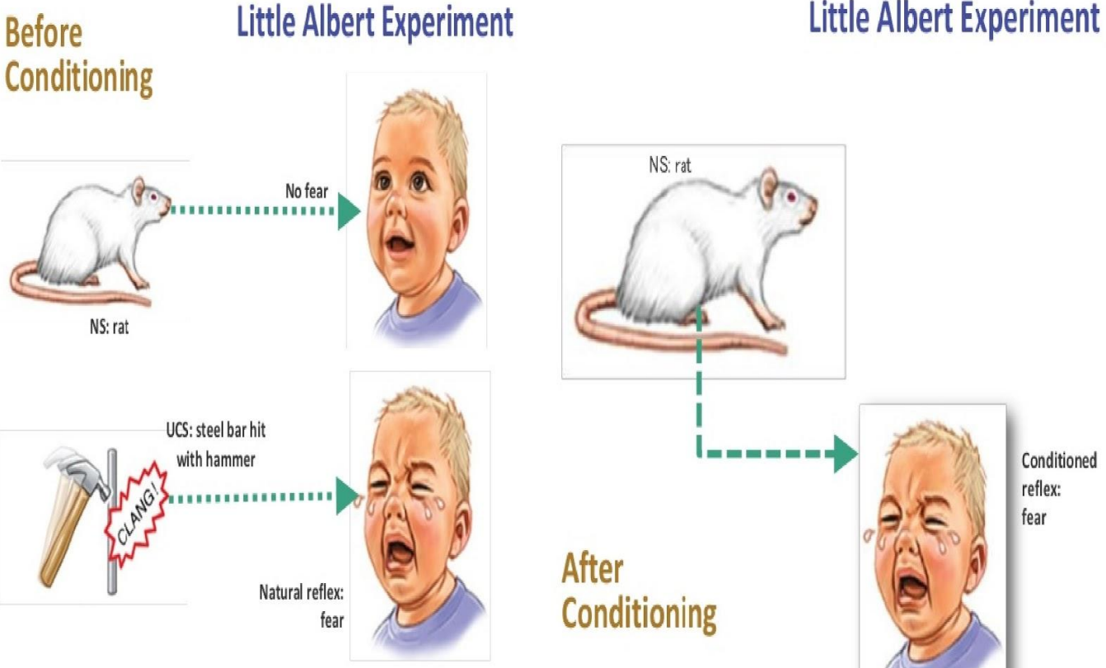

B.F. SKINNER
❑B. F. Skinner (1904-1990) was an American psychologist known for his impact on behaviorism.
❑In a 2002 survey of psychologists, he was identified as the most influential psychologist of the 20th century.
❑B. F. Skinner was a behavioral psychologist who was convinced classical conditioning was too simplistic to constitute a comprehensive explanation of complex human behavior.
❑He believed that looking at the causes of an action and its consequences was the best way to understand behavior. ❑He termed this approach, which looked at the effects of the behavior, operant conditioning

B.F Skinner Theory of Learning: Operant Conditioning
❑According to B. F. Skinner's theory of learning, our behaviors are developed or conditioned through reinforcements. ❑He referred to this process as operant conditioning, with operant referring to any behavior that acts on the environment and leads to consequences.
Taking issue with the limits of classical conditioning, B. F. Skinner distinguished between two types of behavior:
Respondent behavior – things which happen automatically and reflexively, e.g. pulling your hand away from a hot stove. These are not learned behaviors; they simply occur automatically and involuntarily.
Operant behaviors – things which require our conscious control. Though some may occur spontaneously or purposely, it is the consequences of such actions which then determine whether these actions recur in the future. Our actions upon our environment, and their consequences, play an important role in the learning process.

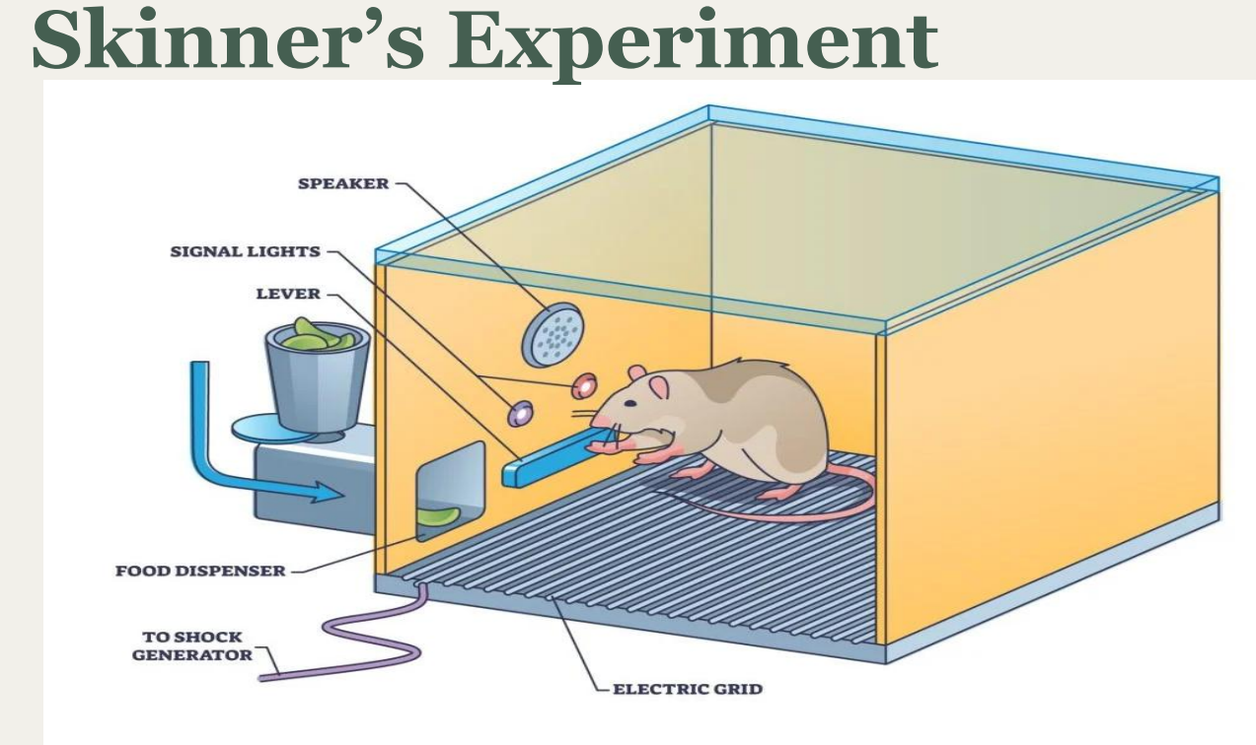
Skinner’s Rats: “changing of behavior by the used of reinforcement which is given after desired Skinner had rats in cages, and they response “received food when they pushed a lever down” Eventually the rats realized that pushing the lever down gave them food, so they did it more and more frequently. Skinner added a negative enforcement in the form of an electric grid. This reinforced the behavior by the rat wanting to make the punishment stop.
Skinner gives impotence to operant behavior which is more concerned with response (R), than with stimuli (S). He calls it R-type conditioning
He changed the usual S-R formula into R-S formula
The reinforcement must come after the response has been made, and not before it.
To make this process easier to remember, the ABCs of behaviorism were developed. The ABCs are antecedent (stimulus), behavior (response), and consequence (reinforcement).
Positive reinforcement
- Involves adding a desirable stimulus to increase a desired behavior
- Examples include praise, rewards, or privileges
- For example, giving a child a sticker for completing homework
Negative reinforcement
- Involves removing an undesirable stimulus to increase a desired behavior
- Examples include removing a curfew or allowing an employee to leave work early
- Negative reinforcement is not the same as punishment
Punishment
❑Punishment is the application or removal of an outcome which brings about a decrease in the targeted behavior.
Positive punishment adds an unpleasant consequence to discourage a behavior, while negative punishment removes a desirable stimulus to discourage a behavior. Both can be effective, but punishment should be used as a last resort.
Positive punishment examples
- Giving a child extra homework
- Giving a child a timeout
- Spanking a child
- Making a child do chores
- A teacher reprimanding a child for picking their nose
- A parent scolding a child for wearing their favorite hat to church
Negative punishment examples
- Taking away a child's favorite toy
- Taking away a child's screen time
- Not allowing a student to play during recess
- Using a swear jar, where a child must put money in the jar for each swear word
